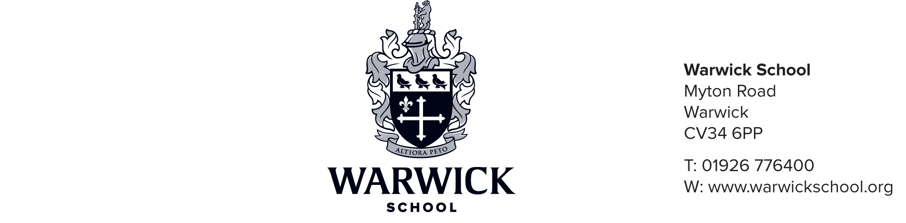

Music Scholarships at 11+/13+/16+
Information for Parents

Music Scholarships are awarded each year to boys entering the Senior School at 11+/13+/16+. Assuming that a satisfactory level has been attained in the Entrance Examination, scholarships are awarded on assessment of musical and technical ability, achievement, enthusiasm and potential.

Music Scholars are expected to play a full and exemplary part in the musical life of the School, supporting and leading appropriate musical activities as advised by the Directors of Music (Performance and Academic). This includes participation in instrumental and choral groups. Music Scholars are expected to take Music at GCSE level and are encouraged to study Music at A level, although it is not mandatory.

Responsibilities of a Warwick School Music Scholar
- Be a role model and inspire a love of music in others
- Contribute wholeheartedly to the rich musical life of the school
- Participate willingly in school ensembles
- Engage with music and grasp the opportunities that Warwick School offers
- Practise regularly
- Attend rehearsals punctually, help set up and tidy away afterwards
In summary, we hope that Music Scholars will:

- Develop their talents through dedicated practice and performance
- Have a real desire to share their talent with others
- Contribute wholeheartedly to the life of the Music School

Music Scholarships are offered up to the value of 20% of tuition fees for day boys and boarders. All scholarships may be enhanced after means testing with a bursary of up to 100% of fees. The actual assessment is made on parental net income and further details can be obtained from the Foundation Office. Music Scholarships may not normally be held in conjunction with any other Scholarship.

September 2019 entrants:
Applications should be received by Wednesday 31st October 2018
Auditions will be held on Thursday 8th November 2018

Audition Information
There is no absolute standard required for an audition, as both musical ability and potential are considered during the process. As a general guide, candidates are anticipated to be Grade 5 standard or above. The Director of Music is happy to hear candidates informally to offer advice and guidance.

There are no conditions about the type of musical instrument appropriate for the award of a Music Scholarship.

An accompanist from the school will be available on the day, however, candidates are welcome to bring their own piano accompanist to the audition should they wish to. A member of staff or parent may accompany the candidate to the audition; parents are not permitted to remain in the room during the audition.

Audition Procedures

Practical Test

a) The performance of two contrasting pieces of the candidate's choice on their first
instrument/voice
b) The performance of one piece of the candidate's choice on their second instrument/voice
c) The performance of one piece on the candidate's third instrument (optional)

Aural Tests

a) To sing a short melody after hearing it played twice on the piano
b) To sing any note of the major scale after the key chord and key note have been sounded
c) To clap a rhythm pattern after hearing it played twice
d) To say whether a short passage is in a major or minor key

Interview

Candidates will be asked about their musical experiences and about the music they enjoy. The audition will last no more than 20-30 minutes and it is hoped that candidates will find the audition to be a friendly and positive experience.

WARWICK SCHOOL MUSIC SCHOLARSHIP APPLICATION

September 2019 entrants:
Applications should be received by Wednesday 31st October 2018
Auditions will be held on Thursday 8th November 2018

Please send the completed application form to:

The Admissions Registrar
(Music Scholarship Application)
Warwick School
CV34 6PP

Application for Music Scholarship at 11+/13+/16+ (please circle as appropriate)

Candidate’s full name: ........................................................................................................................................

Address: ..............................................................................................................................................................

Telephone Number: ............................................................................................................................................

Present School: ...................................................................................................................................................

Instrumental Experience

First Instrument: .................................................................................................................................................

Most recent examination taken (if any) and results: ..........................................................................................

Name of Examination Board: ..............................................................................................................................

Length of time learning: ......................................................................................................................................

Teacher’s name: ..................................................................................................................................................

Second Instrument: ............................................................................................................................................

Most recent examination taken (if any) and results: ..........................................................................................

Name of Examination Board: ..............................................................................................................................

Length of time learning: ......................................................................................................................................

Teacher’s name: ..................................................................................................................................................

Third Instrument (optional): ..............................................................................................................................

Most recent examination taken (if any) and results: ..........................................................................................

Name of Examination Board: ..............................................................................................................................

Length of time learning: ......................................................................................................................................

Teacher’s name: ..................................................................................................................................................

Most recent Theory Examinations taken: ...........................................................................................................

Examination Board and results: ..........................................................................................................................

Orchestral/Band/Ensemble/Choral experience: .................................................................................................

.............................................................................................................................................................................

……………………………………………………………………………..............................................................................................

……………………………………………………………………………………………………………………………………………………………………….

……………………………………………………………………………………………………………………………………………………………………….

……………………………………………………………………………………………………………………………………………………………………….

……………………………………………………………………………………………………………………………………………………………………….

……………………………………………………………………………………………………………………………………………………………………….

Audition Programme

Principal instrument: ..........................................................................................................................................

1st piece title and composer: ..............................................................................................................................
2nd piece title and composer: …………...................................................................................................................

Second instrument: ............................................................................................................................................

1st piece title and composer: ..............................................................................................................................
2nd piece title and composer: …………...................................................................................................................

Third instrument: ................................................................................................................................................

1st piece title and composer: ..............................................................................................................................
2nd piece title and composer: …………...................................................................................................................

I have read the information regarding the Music Scholarships and agree to abide to the conditions set down therein.

Signed: ................................................................................................................................. (Parent/Guardian)

