The Wall Notes

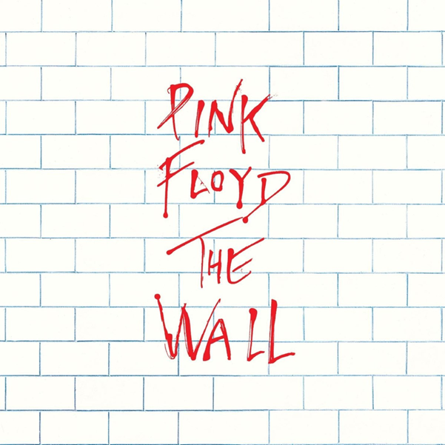
The Wall (1975)
Pink Floyd’s The Wall was their eleventh studio album, released on 30th November 1979 on Harvest and Columbia records. It represents Pink Floyd’s most culturally diverse and expansive album as a rock opera about Pink, a drug-taking Rockstar who through social paranoia has isolated himself from society.
This record was written by Roger Waters, as a semi-autobiographical articulation of his post-war experiences. It is the definition of a concept album, an artistic musical vision with a cycle of songs which express a particular theme or idea. This is different to a normal album, such as Fleetwood Mac’s Rumours, in which one idea/story is presented per song- in The Wall, all songs form a piece of an overall narrative, from Pink’s paranoid childhood to his disillusioned adulthood. The concept album was a staple of Pink Floyd’s work- Dark Side of the Moon and Wish You Were Here were designed to create a unique listening experience rather than to land musical hits.

Roger Waters
Roger Waters was born on the 6th September 1943 in Great Bookham, Surrey. He co-founded ink Floyd in 1965 alongside Syd Barrett and David Gilmour. Water’s early life became the foundation of the Wall’s first side, whilst the eventual hatred of his godlike-status as a Rockstar (culminating in him spitting on a fan during the 1977 Animals tour) inspired him to combine all detriments of Rockstar lifestyle to form Pink’s adulthood, partly basing him off his fallen band member Syd Barrett. Barrett, who was the band’s creative force behind their first album The Piper at the Gates of Dawn (1967), was ousted from the band in 1968 following rumours of mental illness and drug use, before retiring from music altogether in 1972, remaining a recluse until his 006 death at age 60 from pancreatic cancer.
Roger’s father Eric Fletcher Waters was a Communist party member and Labour Activist. After abandoning his pacifism he entered the 8th Battalion of the Royal Fusiliers as a Second Lieutenant on 11 September 1943. He lasted only 5 months before being killed at Aprilia during the Battle of Anzio, leaving his wife Mary to care for her two sons. Water attended the Cambridgeshire High School for Boys and was also a pacifist, becoming chairman of the Cambridge Youth Campaign for Nuclear Disarmament. As you might expect, Waters hated school and viewed it as an oppressive regime- ‘the same kids who are susceptible to bullying by other kids are also susceptible to bullying by the teachers’. Water met Barrett at school, whilst Gilmour lived in the same neighbourhood.

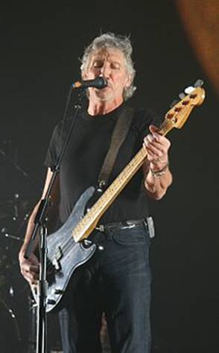
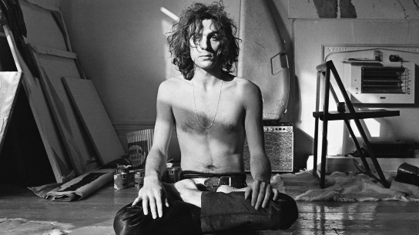


Clockwise, from left to right- Roger Waters, David Gilmour, Syd Barrett

Popularity and critical acclaim
The Wall achieved international success on both sides of the Atlantic, as it topped the US album charts for 15 and reached number three in the United Kingdom. Another Brick in the Wall, Pt. 2 became the band’s only US number one single, and Comfortably Numb went Gold in the UK before being voted as having the greatest guitar solo of all time by Planet Rock.
Many people who first reviewed the album though it overblown and pretentious, as a project much longer than both Dark Side of the Moon and Wish You Were Here, which had a combined 15 tracks as opposed to The Wall’s 26. However, a deeper understanding of Water’s perspective has enabled this album to become one of the most venerated records of all time, selling 19 million copies 1979-1990, second in the band’s discography only to Dark Side of the Moon, which is the best-selling album ever released at over 45 million copies. Kurt Loder of Rolling Stone magazine states that the album ‘leaps to life with a relentless lyrical rage that’s clearly genuine and, in its painstaking particularity, ultimately horrifying’.

Analysis of Track List

- In the Flesh?

Overview: Much in the vein of an unreliable narrator, Pink invites the listening audience to come to one of his concerts- they get more than they bargained for as he begins his narrative.

Researched: The first 15 seconds of this song is sampled from the ending track Outside the Wall. This same beginning and end is common in Pink Floy’s discography- DSOTM begins and ends with a slow heartbeat (Speak to Me, Eclipse) whilst WYWH begins and ends with Shine On You Crazy Diamond Parts 1 & 2. This create a sense that history repeats itself as Pink’s experiences will happen to someone else in time.

It has also been said that “In the Flesh?” represents birth (‘go to the show’). The baby expects love from their parents, but instead see ‘cold eyes’. The background sound effect ‘drop it on ‘em’ represents the harshness of life, as Pink’s first “brick” is laid in the road to ruin through his father’s death.

This song also could be linked to the beginning of the age of celebrity with bands such as the Beatles. Waters resented the godlike persona granted to the audience below his stage, and apparently had visions regarding the blind obedience of his fans, which I think could be linked to the innocence of those sent into war under their superiors working in safety.

Song and Lyrics: The song opens with a thunderous and cool classic electric guitar instrumental, which has a climactic element to it as if the song is building towards Pink’s reveal. At the same time however, the song is droning and gives you the sense of a downward spiral, which culminates in Pink’s anticlimactic appearance, more drug than consciousness. Behind the stage, the band’s own Richard Wright was struggling with cocaine addiction.

In my opinion this references the intricacies behind the live musical performances to that drove Waters to imagine the wall in the first place. The song opens with a whimsical suggestion of attending a concert- ‘So ya thought ya/Might like to go to the show’, and the attendees clearly expect to witness a great man, a rock god- ‘Feel the warm thrill of confusion/That space cadet grow’. However, it is inferred that Pink reveals himself as a drug addict, far from the superior being the audience expect (‘is this not what you expected to see?’). Pink then makes a visceral invitation for the audience to explore to personal demons (‘the bricks’) and past experiences that have built him: ‘If you wanna find out what’s behind these cold eyes/You’ll just have to claw your way through this disguise’.

- The Thin Ice

Overview: The infant Pink is warned about the abrupt reality of life and how it can be taken from you.

Researched: At the start of the song Pink still has both his parents, as Water’s father wasn’t killed until five months after his birth therefore the opening is more hopeful, but is then sharply countered with harsher music symbolizing his father’s death.

The start of the song uses a lot of conditionals- like “may” and “but” to demonstrate how Pink’s happiness in life isn’t certain. This song emphasizes the lesson that nothing is secure or predetermined no matter a child’s circumstances. “Claw” is used for the second time in as many songs, to show desperation and also has connotations with trying to climb walls.

Song and Lyrics: The song opens with piano and synthesizers, acting as a more sympathetic and calming number with Gilmour’s wailing voice (‘Momma loves her baby, and daddy love you too’). However, Water’s vocals are more cutting and cynical, alongside a tapping piano accompaniment which signals harsher music is ahead. With ‘As you claw the thin ice’, harder rock is introduced which seems to simulate the building of stress.

This song has been heavily associated with the war, and I would link it to Eric Water’s death. Gilmour’s lyrics represent the innocence of childhood looking up to their parents- ‘the sea may look warm to you babe/And the sky may look blue’. From the outside therefore, life appears akin to good weather. However, Water’s lyrics depict the future as harsh and bleak- ‘Skating/On the thin ice of modern life’. The lines ‘Don’t be surprised when a crack in the ice/Appears at your feet’ show the instability and randomness of life, and the emotional challenges that will inevitably confront you. The sea beneath the frozen ice in fact contains the trauma and fears which have been built up from past experiences, locked up whilst the person skates on. When the subject in question falls through, they ‘Slip out of your depth and out of your mind/With your fear flowing out behind you’.

Apparently, there is also an Old Testament concept that sons carry their father’s sins: Pink has to transport his predecessor’s trauma behind him (‘Dragging behind you the silent reproach/Of a million tear-stained eyes’) while trying falling through his own “cracks”. The ‘silent’ aspect of his emotional baggage is an indicator of mental health and suffering in silence.

- Another Brick in the Wall, Pt. 1

Overview: Transition into the young Pink who is pained in having to grow up without a father.

Researched: Each of the three Brick in the Wall songs is about Pink Floyd’s separation from the world- the idea of his father flying across the ocean can be linked to the dead being taken across the river Styx, as well as the physical distance between him and his father burial in Italy.
In each version extra notes are added to represent the development of Pink’s feelings as he gets older- this song therefore has the simplest instrumental. It could be also said that the protagonist here is going through the send stage of Elizabeth Kubler-Ross’ five stages of grief with his anger.

Song and Lyrics: This song instantly begins as a recognizable modification of Another Brick in the Wall Part 2’s instrumental, the quick but subdued guitar instrumental showing the kid to be cycling back and forth within his thoughts. The song is conducted at the same pace as its more famous successor, with Waters’ overlaying wispy vocals punctuated with the occasional ensembled cry from the band seeming ghostly and immaterial, like the child’s thoughts. The guitar riff inserted after the fourth line portrays the kid’s angst at his situation. background spaced-out instrumental emphasized how pink is zoned in within his own thoughts, not paying attention to those around him.

He lyrics in this song are I think heart-wrenching, showing the effects of a boy who has nothing to remember his dad by. The line ‘Daddy’s just flown across the ocean/Leaving just a memory’ appears ethereal and angelic, with the ocean perhaps possessing the same association with fear as the sea in The Thin Ice- Pink’s father has been assimilated into Pink’s negative thoughts. The boy can barely remember his father, with ‘A snapshot in the family album’ emphasizing his brief influence. The anaphoric repetition of rhetorical questions in ‘Daddy, what else did you leave for me?/Daddy, what d’ya leave behind for me?’ heightens the emotional weight of the boy’s loss as his questions can never be answered. This continues with the symbolic ‘All in all it was just a brick in the wall’ as the construction of Pink’s prison has begun. The quiet noise of children in the background during the second half of the song show how he is isolated from them.

- The Happiest Days of Our Lives

Overview: Pink’s experience of being relentlessly bullied by teachers at school is vividly revisited, as is their motivation for causing pain on others.

Researched: Induces a bit of karmic irony into the album through the cycle of pain which also infect the teachers. Waters himself said that the song references teachers who try to ‘crush children into the right shape, so that they would go to university’ and ‘do well’ a place which he himself was unhappy at (having gone to Regent Street Polytechnic and losing interest in his studies). In the movie, each teacher adjust their clothes like a uniform before they leave the room an then walk down the hall in single file like soldiers in a regime.

Song and Lyrics: This song the one it introduces are some of my favourite music from the whole album. Most of this LP actually is composed of musings and feeling about Pink’s situation and his fears: on most of the songs, Pink wants to seal himself off from his problems rather than confront them. However, these two songs stand out as both youthful and rebellious, an actual confrontation of the teachers in Pink’s school and the reasons why they abuse the children. Of course, this is all in Pink’s imagination, daydreams during class, and rebellious attitudes had not yet sufficiently arisen in a Britain where old ways still dominated. Still, I would encourage anyone listening to Another Brick in the Wall Part 2 to first listening to this as its introduction- the two songs interact really well.

The Happiest Days of Our Lives is essentially a climax to the explosion of feeling released in its subsequent track, listing the crimes of the teachers and their reasons for bullying the boys. I love these tracks not only for their groovy style but also for the ad libs of the teacher, depicted so well through Alex McAvoy as a sociopathic dictator who takes out his inner pain on his pupils. The track opens with the drone of what seems to be a helicopter, patrolling the school from above. This noise is soon revealed to be the teacher, shouting like a prison officer through a microphone: ‘You! Yes, you! Stand still, laddie!’. The subsequent hard baseline then takes us inside Pink’s mind, where he begins to recount the ‘crimes’ of the teachers as the speed of the baseline steadily increases, symbolising his building anger. Waters lyrical delivery here is masterful, as he sounds more angry than anywhere on the album, almost sneering viciously at the with the word teachers. I think that the lines written for this song are some of the most important and powerful for understanding the social context of Pink’s childhood, something which if skipped over (as I have seen some Americans do) will leave you ignorant of Pink’s reasons to be angry. Though they are short, they contain just a few lines an encapsulation of 1950s school life- ‘When…when…when we grew up and went to school/There were certain teachers who would/Hurt the children in any way they could/By pouring their derision upon anything we did/Exposing every weakness/However carefully hidden by the kids’. After this point in the song, the beat quickens once more and Waters transitions into an even more expressive howling as he reveals what motivates the poor teacher- ‘But in…but in the town it was well known/When they got home at night/Their fat and psychopathic wives would thrash them/Within inches of their lives’. The teacher is stuck in a dreadful marriage which makes him mortified at the thought of going home. After the conclusion of these lyrics, the song enters into a big orchestral climax (with percussion in the background) ended by what sounds like a screaming missile as Pink’s thoughts descend into the anarchy of Another Brick in the Wall Part 2. I also like the title of this song, as it refers to what adults often say when children complain about having a harsh school experience- “you’ll never be this happy again”. This downright dreary sentiment is therefore ironically depicted by Waters.

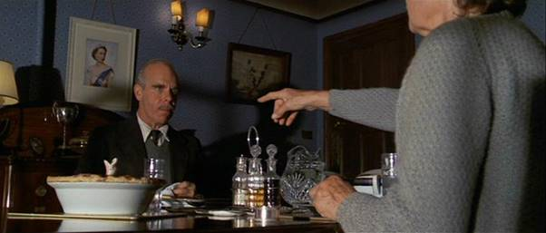
A cute touch that I realised when watching the sequence from the film: before The Happiest Days of our Lives begins, the teacher humiliates Young Pink in front of the class by reading out poetry he has written (‘Poems everybody! The laddie reckons himself a poet!’). The verses he read out are lyrics from Pink Floyd’s song Money from Dark Side of the Moon- ‘Money! get back/I’m alright Jack/Keep your hands off of my stack/A new car, caviar, four star daydream/Think I’ll buy me a football team’. The teacher proceed to savagely scold him (‘Absolute rubbish, laddie! Get Back to yer work’) ignoring his creativity completely and exhibiting the limiting potential of schools.

- Another Brick In the Wall, Pt. 2

Overview: The albums most famous song further visualises the effect the bullying teachers have, whilst incorporating Pink’s wish to rebel and deal damage to those building his wall.

Researched: This song is more complex than part one as it shows Pink’s burgeoning artistic imagination that cannot be suppressed, no matter how hard the teacher tries. The teachers verbal lesson ‘If you don’t eat yer meat you cant have any pudding!’ alludes to the philosophical notion that you can’t have the good without the bad, something which would be used as an excuse for harsh punishments into school as they led to “results”. Floydian Brad Kaye theorizes that the children singing in unison in a cult-like fashion shows Roger Waters’ determination to show that even through rebellion there is conformity- the children are all subservient to those leading just as they would be in normal school proceedings. This single certainly had an incredible amount of societal change around the world- its rebellious message was so influential, whether intended or not, that some states such as South Africa have banned the record from their radio stations entirely.

Song and Lyrics: This is the most famous song on the album, and definitely the most accessible, with an instrumental that you could easily dance too. In the first section of the song, Waters resumes his deep and wispy lyrics shown over previous tracks, although this time with a more threatening and omniscient tone, whipping the children up for rebellion. It is clear that the anger is coming from the children with the colloquial double negatives which Waters uses throughout the chorus- ‘We don’t need no education’. The repetition of the chorus throughout the song make it seem like a ritualistic chant which awakens children from their prisons. The Orwellian view of school propagated throughout the album is personified in ‘We don’t need no thought control’. The psychological bullying commonly dismissed as “character building” at the time is also attacked- ‘No dark sarcasm in the classroom’. The subdued line (almost said under his breath) ‘Teacher, leave them kids alone’ transitions into a direct address to the teacher as Pink’s confidence builds- ‘Hey, teacher, leave them kids alone!’. The repeated syntax of ‘All in all, your just a/nother brick in the wall’ of course links to the previous idea of pink’s bricks being laid, which lead to problems later on; however, it has also been interpreted in popular media as an attack on the educational system of a different kind- that school merely serves as a factory “manufacturing” children to be homogenous parts in a greater machine. This is depicted incredibly chillingly in the film, with rows of children clad in hideous mass robotically marching into blenders to be spat out as paste for society to consume. After the first verse, the beat stops momentarily and the song fades into silence barring the sharp hi-hats of nick Mason’s drums, before being superseded by a choir of schoolchildren mindlessly reiterating the chorus- the rebellion is in action! Pink’s fantasy ends with a marvellous guitar solo (by David Gilmour) during which the uprising takes place, Young Ones-style, with classrooms trashed, teachers carried out of their offices and the whole school set on fire.

Again, you have the hilarious Scottish teacher coming back into the record once Pink’s fantasy has dissipated and he returns to the real world- ‘If you don’t eat yer meat, you don’t get yer pudding! How can you have any pudding if you don’t eat yer meat!’, ‘You- yes, you behind the binsheds! Stand still laddie!’.

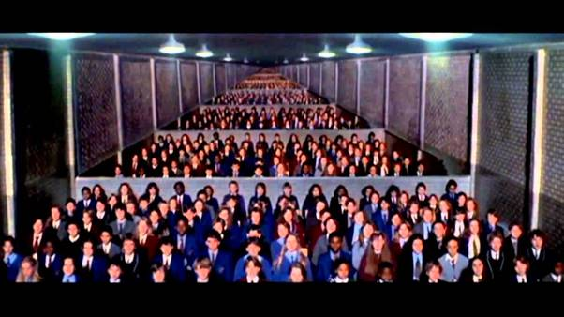

- Mother

Overview: Pink demonstrates his curiosity about the world around him, which ends in his mother becoming dangerously over-protective and scaring her child with her own fears.

Researched: Pink’s fear that ‘they’ll try to break my balls’ shows his personal emasculation through a harsh school life. Ink’s childhood sickness is referenced in the alternate link ‘am I really dying’, which reinforces the gloomy idea brought up in The Thin Ice life is just a slow death. Waters himself may have introduced the possibility in overprotection from his mother during childhood by stating ‘if you can level one accusation at mothers it’s that they end to protect their children too much’. It has also been suggested that Pink shares a similar relationship with his wife as he does with his mother, with her also referring to him as ‘baby’ and being overprotective- this is a reasonable assumption considering that she appears in the song to have been approved by Pink’s mother herself. Pink therefore comes to view girls as he did his infant mother, imposing and maternal.
Songs and Lyrics: This song is one of my favourites, and is whilst I would say it was relaxing to listen to, and sound understanding of the lyrics certainly makes it more creepy and introspective. The use of a repeated simple acoustic chord instrumental with no fancy/grandiose backing instrumental in my opinion makes it feel more homely, and something more in tune with a bedtime story than a drug-induced fantasia. Another thing that I love about this track is the progression and alteration between Waters and Gilmour as lead vocalists in order to represent different characters. Waters, with his more subdued, deep but croaky vocals represents the concerned child who is curious about the world and constantly encroaches upon his mother’s fears in his attempts to understand it. In turn, Gilmour’s higher, more sophisticated lyrics personify the supposedly calming (but subliminally overprotective) reassurances of Pink mother.
As an English student I can appreciate the literary techniques that Waters has used to define child from parent in this song. He uses the anaphoric repetition of ‘Mother, do you think’ and ‘Mother, should I’ to emphasize the child’s curious nature- every single line uttered by Pink in this song is in fact a question. This really helps to convey the youth’s concerns, which for the large part go unanswered and become rhetorical. In contrast, the mother’s tone is patronizing with her repeated use of baby’ and ‘babe’ to refer to the boy; Pink is old enough to ask complex questions but Mother still treats him as an infant- ‘Hush now…don’t you cry’. This problem is exacerbated as the song progresses- Pink begins to become involved in romantic relationships (‘Mother, do you think she’s good enough—for me?’) but still his Mother insists on controlling him for his own safety (‘Mama’s gonna check out all your girlfriend for you/Mama won’t let anybody dirty get through’). From this, the parent’s actions appear decidedly more Orwellian as she becomes a ‘Big Mother’ who constantly surveys and controls her child-‘Mama will always find out where you’ve been’. Again, we see Waters occasionally using increased stress and volume in his voice on select lines in order to convey Pink’s occasional anger in his questioning- this is mainly linked to concerns over his father and the war, shown through ‘Mother, will they put me in the firing line?’ and ‘Mother, will she tear your little boy apart?’. This is however quickly countered afterwards by the soothing low “Ooo-aaah’s” which show him calming down.

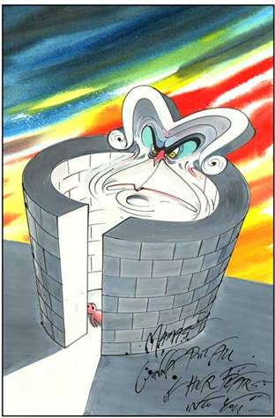
Mother barely disguises its association will the social paranoia which plagued post-war Britain. The very first line is a CND-esque concern about the future of weaponry: ‘Mother, do you think they’ll drop the bomb?’. The high expectations laid upon children at the time are also covered (‘Mother, should I run for President?’). Similarly present is the fear of being sent out into a future conflict to save a deceitful government spouting war propaganda: ‘Mother, should I trust the government?’ shows the spread of misinformation after the war, whilst the aggravated ‘Mother, will they put me in the firing line?’ demonstrates a concern that he could be sent to his death in battle like his father. Analysis of the mother’s lyrics reveals that her motivations are in fact extremely self-centred, using her child as an outlet for her own paranoia; ‘Mamma’s gonna make all your nightmares come true/Mamma’s gonna put all her fears into you’. Waters uses the a bird’s nest metaphor to illustrate the captivity of her child, and how her overprotectiveness isolates the kid from the world: ‘Mamma’s gonna keep you right here under her wing/She won’t let you fly, but she might let you sing’. In other words, Pink’s mother, like his teachers, serve as another brick in his wall. This is most clearly demonstrated through ‘Of course mamma’s gonna help build a wall’, a process that the fearful child initially welcomes, but begins to question once he realizes his isolation- ‘Mother, did it need to be so high?’.

- Goodbye Blue Sky

Overview: Pink’s transition from home to the outside world is mixed with a country recovering from armed conflict, paranoid about the future.

Researched: The child’s voice in the song is young Pink, and was recorded by Roger Waters’ own son Harry, which adds a bit of realism to the boy. Critics have said that in the eponymous lyrics ‘Goodbye, blue sky’ The Wall’s protagonist is leaving his childhood innocence as ‘Baby blue’ behind for the more emotional and sexually charged character “Pink”. The line ‘Brave New World’ may invoke either Alduous Huxley’s novel or Miranda’s lines in The Tempest wherein she talk about ‘How many goodly creatures are there here/How beauteous mankind is!’. The phrase is therefore juxtaposed cynically with the war, pointing out man’s capability to inflict death and destruction despite its supposed pretty features. As in Huxley’s technologically advanced “Utopia”, something that is brave and new is not always moral.

Songs and Lyrics: The importance prevalence of nature is introduced right from the beginning of the track, with the introduction of birdsong, and the “innocence” of a child’s youthful voice: ‘Look, mommy. There’s an airplane up in the sky’. This however becomes instantly ominous given the listener’s awareness of Britain during the Blitz, and introduces the idea of this natural beauty being destroyed. The initial tab which is played is heart-warming, giving the impression of sunshine or even happiness. However, this is predictably interrupted by ominous droning synthesizers which quickly lower the tone of the music into something more dark: the bombers have been introduced into the night sky.

Harmonised ‘Oooooo-ooooo-ooo-ooo’ sounds combine with the instrumental to introduce an element of contemplation to the song. This peace is disturbed by the se of onomatopoeic repetition of ‘Di’ di’ di’ did you see the frightened ones?’ to demonstrate fear and panic amongst the blitz. More blitz imagery is invoked with ‘did you hear the falling bombs’ and ‘had to run for shelter’. In the second half of the song Waters invokes pre-war optimism and talk about the lasting effect of the war which Britain felt for years after with rations remaining and poverty multiplying- ‘The flames are all long gone, but the pain lingers on’. Hope is abandoned with the final nostalgic lines ‘Goodbye, blue sky’.
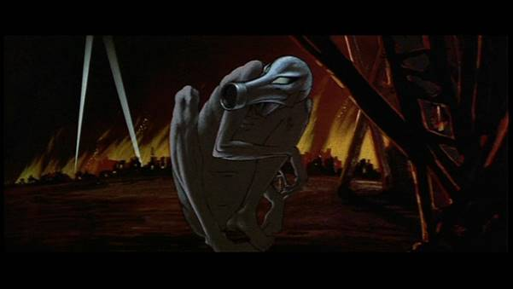

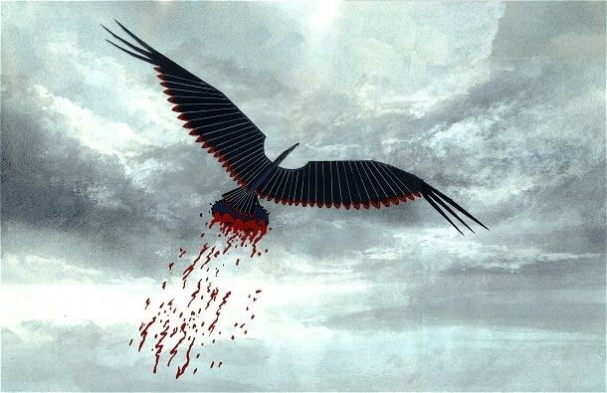

- Empty Spaces

Overview: Pink questions his freedom to an ambiguous listener, and how to finish his wall.


Narrative leap in which seems to make the transition awkwardly from Pink’s childhood into his adulthood. The track features a secret message which mentions Roger Waters’ actual wife Carolyne who had apparently called her husband at the time in which he was recording the album. Waters has said that without Carolyne’s support and insistence on communication he himself would’ve ended up as an extension of Pink- like Pink he also needed a feminine (possibly even maternal) figure to break him down and force him to open up. Adam Marcotte explores the use of the telephone in his critique of Empty Spaces, remarking how the telephone is used throughout the album to demonstrate the potential of communication, and how the characters fail to use it sort out their own problems which makes them more tragic.

- Young Lust

Overview: Pink becomes a Rockstar and becomes a personification of that lifestyle, one of sex drugs and rock and roll.

This song is the most orthodox of the whole album, with its allusions to a hedonistic life being portrayed through many other rock forms both before and after the song was released. Before the rise of Rap music and especially Gangsta Rap in the early 90s, rock bands were recognised as some of the world’s most notorious touring acts. Perhaps the greatest rock band of all time Led Zeppelin were infamous for their destruction of hotels and numerous high-profile orgies. Drummer John (‘Bonzo’) Bonham, widely considered the best percussionist of all time, died at the age of 31 in 1980 after choking on his own vomit. In the late 80s and early 90s, Guns N’ Roses were often divided by the escapades of legendary guitarist Slash, who took a pet lion called Curtis on tours, and once ran naked through Arizona convinced he was being chased by the Predator alien from the famous 1987 movie. Maybe some of the most infamous Hard Rock and Arena rock bands after Zeppelin were also infamous for their behaviour. The most high-profile of these were Kiss’ Gene Simmons, who claimed to have slept with over 1000 women, and Motley Crue’s Nikki Sixx overdosed on heroin a dozen times, even being legally pronounced dead for two minutes at one stage. The Rolling Stone were the pioneers of the bad boy lifestyle, led by guitarist Keith Richards and vocalist Mick Jagger, the latter of which has fathered 8 children with five women. Pink Floyd were not immune to this bug, as the departure of Barrett and the cocaine addiction of Richard Wright and David Gilmour.
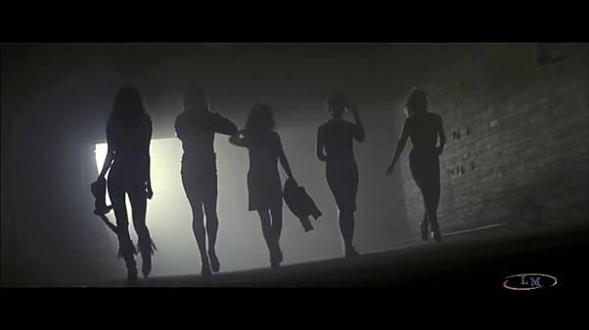
Young Lust essentially serves as a demonstration of Pink’s obsessive and hedonistic behaviour which begins after he is finally freed from the overprotective clutches of his mother.

- One of My Turns

Overview: On this song, the audience is awakened to the possibility that Pink’s wife is having an affair, an ironic twist for Pink regarding his infidelity. In this song, Pink invites a groupie to his room but has an emotional outburst that he is unable to contain, frightening her away.

Every element of the album up to this point has, no matter how explicit the material, shown Pink progressing into adulthood and constantly evolving. This song however is the first time that we witness Pink hitting a roadblock and actively coming to a standstill, debating whether he should continue along his current course of life. The girl which Pink brings back to his room is unable to emotionally satisfy him in light of his wife’s cheating, and Pink feels emotionally wrecked as a man who has got ‘everything but nothing’ due to his fractured emotional base which is crumbling away. Pink’s liability to take his wife’s companionship for granted is why he feels so emotionally bankrupt when she betrays him, and decides that he is unable to trust any woman. Pink is frequently depicted in the chair watching his TV in this and subsequent scenes, as it is his only portal to the outside world. The film on the television in this scene is the Dam Busters, which not only evokes memories of the war for Pink but also can be associated with breaking through one’s limitations, in this case Pink’s wall.
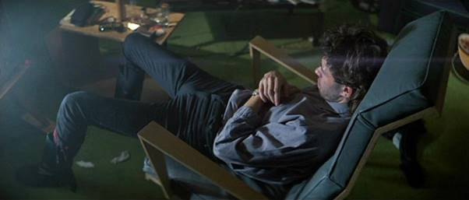

- Don't Leave Me Now

Overview: Pink confronts his wife, and is torn between the desire to physically push her away and his need to engage with a comforting partner.
The lyrics of this song are extremely threatening and tinged with domestic violence, but it is debatable as to whether Pink has the willpower to actually perform these acts or whether he simply imagines them alone. In this scene Pink is self-pitying, and views his wife’s betrayal as another predetermined brick in his psychological wall, when in actual fact his problems are avoidable with a little effort on his part. Although it is true that others have harmed Pink, he too has a part to play in his own destruction. The repetition of ‘oooooh, babe’ throughout the song is a reiteration of lyrics found in Moher, again drawing parallels between his parent and his wife.

- Another Brick In the Wall, Pt. 3

Overview: In this song, after frequent questioning of his own goals, Pink decide that his wall is complete and that he feels comfortable isolating himself from the world.
Pink begins the scene in the film by rejecting reality and the outside world by smashing the TV playing the WW2 movie. This is symbolic as an attack on the outside world which Pink believes has so actively wronged him. Water described this song as Pink’s decision to accept the possibility of isolation as the final mental brick in his wall where he (most likely because of his hedonism and his wife) had previous deemed it to be impossible. Pink invokes the albums cover in his claim that there is writing on the wall, which again references the Old Testament story of King Belshazzar, who receives an omen scribbled on a wall interpreted by the prophet Daniel as marking his doom.

- Goodbye Cruel World

Overview: As is indicated by the lyrics ‘I’m leaving you today/Goodbye all you people/There’s nothing you can say/To make me change my mind’, Pink has shut himself off from society. The song title, although it is usually used (whether comedic or otherwise) to indicate that a character is on the verge of physical death, Pink’s is a subjective death. This song is very peaceful, as it represent what Pink interprets as a cathartic release from all the problem which have afflicted him at this stage in his life. It also serves as a metaphor for the wall, as nothing can be heard from the outside.

- Hey You

Overview: Pink feels isolated (predictably) after making the decision to shut himself behind his wall, wondering if he had in fact done the right thing.

Researched: This song was not included in the movie after being cut in light of what was deemed to be narrative and thematic clashes with others sounds around it in the album. In his attempts to reach out to others, Pink reveals his egotism as he cannot imagine anybody happy, without being ‘lonely’ or having ‘fading smiles’ as he had. Pink’s final call for someone to help him carry the ‘stone’ mimics the overwhelming burden held by Sisyphus of Greek myth, and could be interpreted as genuine or just Pink overstating his burden. In his reference to those he has shut out, such as his wife and mother, Pink shows himself to be hypocritical and really dependent upon the attention that they give him like any normal person. Waters described the “worms” mentioned as eating into Pink’s brain as physical embodiments of decay.

Song and lyrics: This is one of the song which reach out to the listener on the album, and breaks the wall in the responsibility it places on those who listen to it- it is almost like the ‘Hey you’ is addressing you in person. In this song, Pink realises that he has made a mistake in sealing itself within his own cocoon, and is desperate for someone to free him from his entrapment. The warped baselines and tinkling guitar notes really emphasize the loneliness inside of the sealed wall. In this song, Gilmour acts as the pink calling out to other dissatisfied people to free him- ‘Hey you, out there in the cold/Getting lonely, getting old, can you feel me?’ and ‘Hey you, standing in the aisles/With itchy feet and fading smiles, can you feel me?’. Pink realises the error of his ways and begs others in his position to be compassionate and help him out of his slump- ‘Hey you, would you help me to carry the stone? Open your heart’. However, since he has ditched his only friend nobody cares enough to help him, as represented through Roger Waters’ vocals in the second-half of the song- ‘it was only fantasy/The wall was too high, as you can see/No matter how he tried, he could not break free’, appearing as a quasi-narrator for Pink’s plight. The line ‘And the worms ate into his brain’ represent the seeds of doubt in humanity which have been planted in Pink’s brain during the song. Furious that no one is willing to help him out of goodwill (when in reality no one can hear him to his self-isolation) Pink then begins to harbour an irrational hatred towards the people who he imagines have betrayed him, further exacerbating his victim complex. The last two lines are an appeal for those afflicted with personal issues to be properly helped by those around them , so that they do not spiral in the same fashion as Pink: ‘Hey you, don’t tell me there’s no hope at all/Together we stand, divided we fall’. This snippet of communal spirit, previously rejected by Pink foreshadows his eventual salvation through his family and friends- a message to help those in need.

- Is There Anybody Out There?

Overview: In this song Pink begins to feel progressively more and more lonely which becoming depressed at the thought that he may never knock down his wall.
The lyrics are simply a repetitive ‘Is there anybody out there?’, but this is still one of the most complex songs on the album. In its repeated nature, the song succeeds in making the message in the song more powerful each time. Having received no answer to his question, Pink decides that he has no choice but to retreat further into his dangerous psyche.
The final infamous saving scene references the band’s last interaction with Syd Barrett in 1975. After having isolated himself completely from his band members, Syd returned bald, fat and unrecognizable to his former bandmates as they were working on WYWH, casually walking into the studio, and then leaving after telling the band that their song sounded ‘a bit old’. We can therefore infer that after Pink shaves his eyebrows off (like Barrett had) he had made the decision to isolate himself completely.

- Nobody Home

Overview: In nobody home, Pink runs through the possessions that he hasn’t lost, no matter how inconsequential. This emphasizes his tragic loss of freedom and his visions of how thing’s could’ve been different.
Nobody home serves as the polar opposite of the materialistic young lust, a depressive atmosphere whose fundamental message is that what you physically own is worth nothing in comparison to the emotional value of a proper relationship. Without such relationships, life is slow and dreary. Pink begins to regret his actions, saying that he wishes he could fly, but has ‘nowhere to fly to’. His former actions in severing ties with his former life have left him inaccessible to those who might properly care about him, but not those who wish to exploit him, as we see later. In an originally cut scene from Hey You, the younger Pink meets his older self-, curled up and isolated within his mental prison cell. Horrified by what he has become, Pink realises that although he has been unfortunate, it is his vendetta and unwillingness to accept himself which drags him down rather than the outside world’s inability to accept him.

- Vera

Overview: Vera is actually a reference to Vera Lynn, the popular wartime singer (would’ve preferred George Formby, but I understand). This is a recollection of the hope that Lynn inspired within Britain before its post-war misery. In many ways she represents Pink’s desire to go back to the roots of his personal conflict, before even his first “Brick” was laid. As Pink has ventured further back than any of his problems reach, it is one of the only songs on the whole record in which the subject matter is not divided between two waring feeling or emotions.

- Bring the Boys Back Home
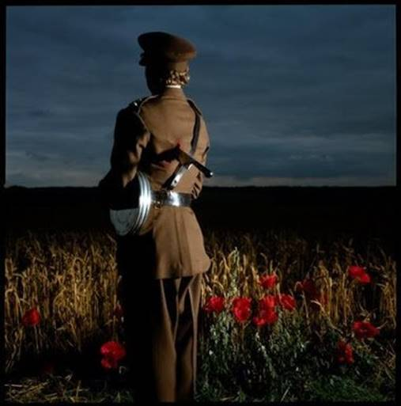

Overview: In this song, the destruction of society which was caused by WW2 is attacked, with calls to bring those lost from their families back into Britain. This is not merely from Pink’s perspective but is from that of Waters’ himself, a pacifist, and is applicable to all wars. Its appeal to ‘not leave children on their own’ by bringing those who fathered them back also forms a solution to Pink’s problem of a lost fatherhood, and is therefore a fantasy for the troubled man.

- Comfortably Numb

Overview: Pink’s self-imposed isolation within his hotel room is interrupted as his money-driven music industry colleagues burst into his room and inject him with drugs to revive him for his upcoming concert.

Researched: Pink’s wall caused things to come through in waves, not solid facts. The ship depicted in Pink’s drug-induced dreams may reference the imagery of ships (as later done on “Southampton Dock” on The Final Cut) associated with soldier’s leaving, or it may represent Pink sinking into his psyche. The pin-prick which the doctor administers to him is viewed by Pink as merely another oppressive mechanism people are using to control him and steer him away from his wall. Roger Waters said in a 1979 interview that managers are ‘not interested in any of these problems. All they’re interested in I how many people there are and tickets sold and the show must go on, at any cost, to anybody’.

Song and Lyrics: My second favourite song from the album. It’s the embodiment of psychedelic rock song and really simulates the experience of being spaced out- I even listened to it to focus before my exams. In my opinion, it has the most coherent and interpretive lyrics out of the whole bunch, along with an absolutely incredible guitar solo from David Gilmour. The instrumental of the song is masterful, creating the illusion of a drugged out experience as you can visualise changing shapes in the synths. The song’s opening, a warped sound which becomes progressively louder appears to simulate either waking up from a stupor (as happens in the song) or receding into one. The sound effects which are scattered throughout the song are brilliant in their simulation of ongoing events- a triangle is used to emphasize the sharpness of the needle, and an agonised cry interrupts the doctor’s lyrics as he inserts it. In the chorus, which is punctuated by David Gilmour’s howling vocals, a new instrumental which alternates up and down seems to depict the nervous stimulation which Pink is undergoing.

The lyrics are quite mesmerising, and show the exploitation going on. Roger Waters is the cynical voice of the doctor, and Gilmour the blubbering Pink estranged from reality. Water’s first lines link well with the idea of Pink shutting himself behind his wall, as the doctor speaks as if calling through a front door- ‘Hello, is there anybody in there?/Just nod if you can hear me/Is there anyone at home?’. The help of the doctor is unsolicited, but he continues nevertheless as he is under contract to get Pink back on stage, which makes him appear more tempting and duplicitous in his aid- ‘Come on, now, I hear your feeling down/Well I can ease your pain/And get you on your feet again. With the chorus comes Gilmour as Pink, coked out of his mind and only partly aware of the doctor’s existence- ‘There is no pain, you are receding/A distant ship smoke on the horizon/You are only coming through in waves/Your lips move but I can’t hear what your saying’. In his fervour Pink can only recall his past trauma, referencing how he feared death due to illness- ‘When I was a child I had a fever/My hands felt just like two balloons’. Pink is now depressed at his situation, and doesn’t want to share it with those in the room- ‘Now I’ve got that feeling once again/I can’t explain, you would not understand’. The doctor, unable to here Pink, merely ushers him towards the stage (‘Can you stand up?/I do believe it’s working, good/That’ll keep you going for the show/Come on it’s time to go’). The song ends with Pink reminiscing on the lost aspirations of his childhood: ‘When I was a child I caught a fleeting glimpse/Out of the corner of my eye/I turned to look but it was gone/I cannot but my finger on it now/The child is grown, the dream is gone’. The depiction of drugs as a journey makes me think of “Golden Brown” but the Stranglers, in which a band member is addicted to the ecstasy of drugs (Never a frown, with Golden Brown), viewing is as a seductive lady: ‘Every time just like the last/On her ship tied to the mast/To distant lands/Takes both my hands’ and ‘Golden Brown, finer temptress/Through the ages she’s heading west’. The cynical depiction of the music industry and its treatment of its stars is prevalent through this song, having been previously featured on Wish You Were Here’s Welcome to the Machine and Have A Cigar.
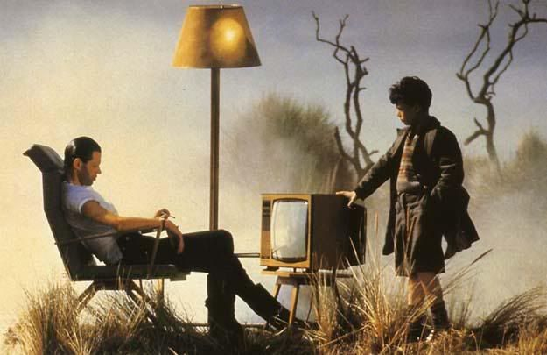

- The Show Must Go On

Overview: Unlike Queen’s inspiring song of the 1980s which called for a positive attitude in the face of seeming doom or death, in this song the title appears to be the singular view of those who want Pink to perform irrespective of his personal condition. However, it could also be interpreted as an act of mental fortitude on Pink’s part as he decides that he must tackle his duties head on instead of shrinking away from them. The more theatrical nature of the song also casts Pink as an actor who is forced to ignore his problems for the benefit of his subservient audience. At first Pink shows a desire to have his fate decided for him, calling back to his parents in a childlike manner- ‘Oooh, Ma, Ooooh Pa Must the show go on?’ before debating ‘Am I too old, am I too late?’. In the end though, he appears to steady his resolve, before once again retreating from the real world behind the wall in his next song.

- In the Flesh

Overview: In an emphatic realization of Roger Waters’ fears regarding the cult of celebrity, Pink imagines himself as a fascist dictator whose audience listens to his every degraded and malformed view, enacting them without question.

Researched: The crossed hammer iconography which was used by Pink Floyd was later adopted by an entirely separate real-life fascist group (obviously unaware of the ironic nature of their branding) called the Hammerskins in 1988. This song, imagined as it is by Pink after he has disconnected himself from society, could also be a reference to the fact that all genocidal and homicidal ideas come from someone having an emotional disconnect in society, such as that frequently demonstrated through incidents such as terrorist attacks, serial killings and political movements like Hitler’s which were based both on a need to self-satiate a dejected ego and to find somebody else to blame for their own failures. This song also has links to the song ‘Sheep’ from Pink Floyd’s “Animals” album.

Songs and Lyrics: Like the 3 ABITW songs, this song transmutes several aspects from the opening track In the Flesh? The opening grandiose and rocky instrumental is the same, but Pink has been replaced with a racist interpretation of his paranoia, likening rock stars and performers to political entities like the Nazis. Mid-track the rock instrumental devolves into harmonised choir singing which is really pleasant but invokes suspicion for what is to come. Indeed it is very bad. In the most cultish and dark song of the album Pink launches a verbal tirade against ethnic minorities (‘That one looks Jewish!/And that one’s a coon!’) and homosexuals, demanding that they should be killed in a brutal fashion- ‘Are there any queers in the theatre tonight?/That one in the spotlight, he don’t look right to me/Get him up against the wall’. The fascist choir (depicted in the film wearing full fascist uniform and singing joyously deliver creepy echoes of Pink’s statements ‘[choir: Against the wall!]. This song serves as a complete rejection of the cult of celebrity and the technique of suggestive racial tactics which is still used for political means through mediums such as those of Donald Trump.

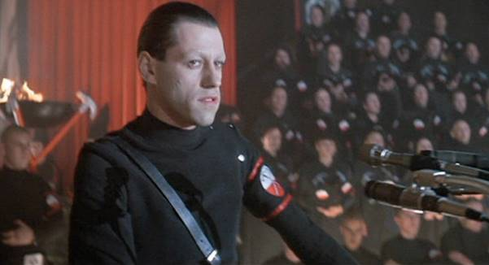

- Run Like Hell

Overview: In this song Pink threatens to physically hurt those who choose to leave the hall of his authoritarian concert- this has connotations with the scare tactics which Hitler used in his ascension to the top of German society, demonstrated in paramilitary incidents such as the Munich Beer Hall Putsch in which he held local politicians hostage.
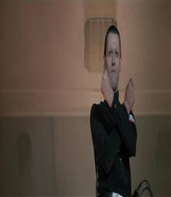
These few songs are almost a collection of Pink fantasizing about other ways in which he might address his pain- in this case by forcing those unlike him to conform to his way of thinking, complete with a crossed hammer salute.

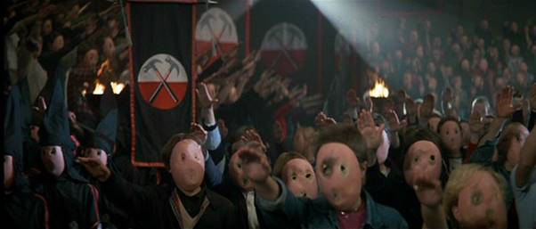
The appearance of the distorted masks seen in ABITW part 2 is reminiscent of the role which education played in the Nazi regime, which relied on the indoctrination of Aryan children through organisations like the Hitler Youth and school, which featured genocidal maths questions as well as biology projects based around the eugenics theory.
The violence carried out by the mob in this scene is actually very upsetting, with hangings and rapes. The danger of this kind of mob mentality, wherein the audience is as much a purveyor of hatred as the leader is (something that is denied by many willing to vote for such leaders today) is very clearly shown. One bright spot from this scene however is that Pink visualising himself as this awful dictator indicates his final rejection of his elevated opinion of himself as a Christlike figure nobody else could understand, but rather a dangerously unhinged individual. An interesting detail is that the crowd chanting in the left audio of the song is saying ‘Pink Floyd’ to represent the band’s socialist beliefs which those chanting ‘Hammers’ emanate from the right, representing their nationalist extremism.

- Waiting for the Worms

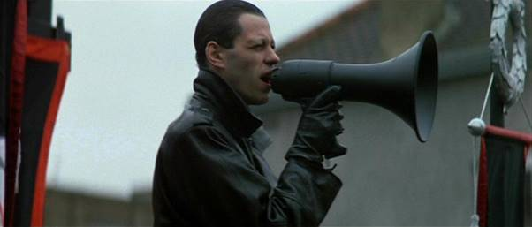
Overview: In this song, pink effectively morphs himself into Hitler through his promotion of ethnic cleansing and therefore comes to represent the very force that killed his father, completing the ironic cycle of his life. It demonstrates the danger (not realised by the western allies, i.e. us ☹) of appeasing egotists who keep feasting on self-platitudes and accelerating their tirades against others. Pink’s personality has moved over three songs from ethnic branding and racism, to more physical forms of segregation, and eventually into outright genocide- just like Nazi Germany. There is very little subtlety as to the source material which the song is referencing, from the German language of ‘eins, zwei, drei, alle!’ to the namedrop of ‘the final solution’, the listing of those persecuted by the Nazis- ‘Waiting for the queers and the coons and the reds and the Jews’ and the methods with which they were killed- ‘Waiting to turn on the showers and fire the ovens’. Nationalism is very evident- ‘Would you like to see Britannia rule again, my friend’ as well as Powellite racism ‘Would you like to send our cousins home again, my friend?’. Comparisons have been made to the BUF marches led by Oswald Moseley in 1936- but although that incident appeared to represent an abandoning of reason from some members of the British public, 300,000 still marched to stop them; like a resurgent Pink, there were still many who resisted the mob mentality.

- Stop

Overview: Pink becomes horrified with what he has become and what he has visualised, decided to stop his ramblings and ‘put himself on trial’ (like Nuremberg) to determine the extent to which he is culpable for his divergent thoughts. The first lyric ‘STOP!’ brings his fascist tirade to a halt, and is depicted ironically in Bob Geldof’s scream from the movie. Pink has had enough of his petty self-indulgence and wants to reunite himself with familiar comforts: ‘I wanna go home/Take off this uniform/And leave the show/But I’m waiting in this cell/Because I have to know/Have I been guilty all this time?’. This is the first time, in a story within which things happen to the Pink and he doesn’t resist out of a self-piteous perception that his fate is inevitable, Pink for the first time decides to actively make a positive change and banish the dictator within.
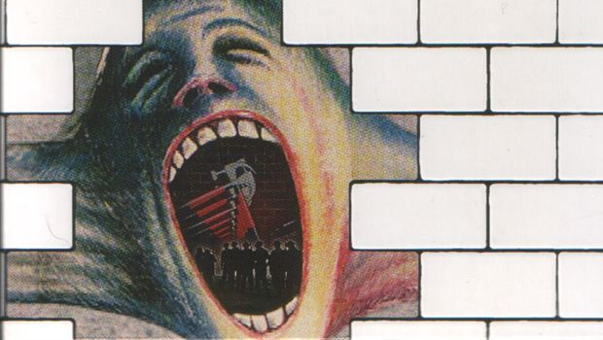

- The Trial-

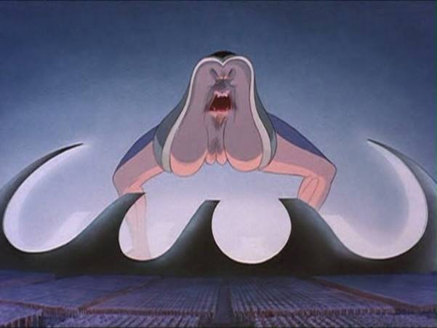
Overview: Pink goes through a trial of his own misdeeds carried out by his own mental “bricks” to decide whether he is capable of redemption. He ultimately decides that he should take responsibility for the making of the wall, but that the regret he showed for his mental crimes demonstrates that he is redeemable. The Trial is a mock court scenarios in which the various different pieces of the wall (including the teacher) offer evidence to the case. Through the evidence presented, Pink is shown to have failed in his attempt to shut his compassion away behind the wall- ‘The prisoner who stands before you/Was caught red-handed showing feelings/Showing feelings of an almost human nature’, a crime not acceptable within the wall. Teacher is summoned - ‘call the schoolmaster!’ and expresses contempt at his failure to pass on his torturous feelings from his marriage onto his pupil (‘I always said he’d come to no good/In the end you honour./If they’d let me have my way I could have/Flayed him into shape’) and expresses his selfish desire to take his anger out on others like Pink- ‘Let me hammer him today’. Pink himself wrenches his psyche back from his evil alter ego and pleads insanity: ‘crazy, toys in the attic. I am crazy. They must’ve taken my marbles away’. After it is revealed that those Pink believed deliberately wronged him still love him- ‘come to mother baby, let me hold you in my arms’. Pink is then “sentenced” to face up to his problems as he always should’ve, without the help of the wall: ‘Since, my friend, you have revealed your deepest fear/I sentence you to be exposed before your peers./Tear down the wall!’. Ultimately, the outcome of the album is a positive one, and not nearly as self-piteous as many people believe it to be on the surface level- according to Chris Wilson, the judge in “The Trial” ‘condemns Pink for selfishness and hurting people who loved him… the album is an exposure of Pink’s narcissism’. Many of the wrongs he thinks he has suffered (from his mum, his wife and his father) are largely imagined.

- Outside the Wall

Overview: The final track solidifies the moral of the story, as said by The Wall Analysis project: ‘though there will almost always be personal and social barriers erected out of fear, oppression, pain and isolation, it’s the job of every socially conscious individual and community to never rest in tearing down the wall that separate us’. All those who go through Pink Floyd’s cycle of depression have to learn that it can be broken by somebody else who truly cares for their fellow people, and that the cycle doesn’t have to end with self-destruction. The final enduring message of the Wall is neither rebellion or brooding nihilism, but that family and friend are truly what is important in life, as shown through the lyrics- ‘The one that really love you/Walk up and down outside the wall’. The song also expresses gratitude to those who have devoted their lives to helping out family members suffering from the same problems a Pink- ‘When they’ve given you their all/Some stagger and fall, after all its not easy/Banging your heart against some mad bugger’s wall’. The lesson is, never stop trying to help those around you- when they recover, they’ll be grateful to you forever.
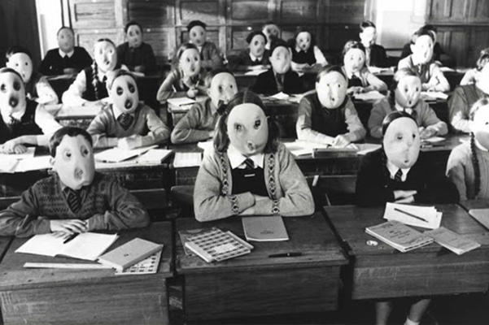
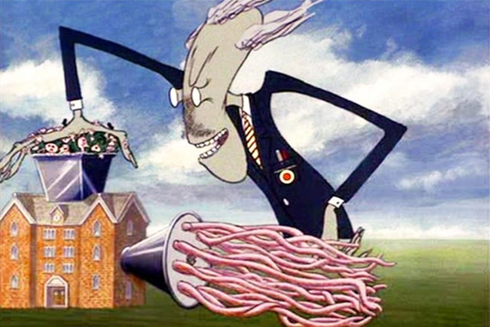


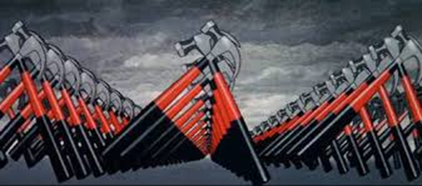

Pink Floyd The Wall Movie
Indie film tie-in which only had a budget of $12 million, and whilst met with muted responses from critics at the time of its release (1982) but has since become a cult classic. This was a musical which based its narrative around the 1979 album which served as the soundtrack for the film. It was directed by Alan Parker, notable director of Midnight Express, Mississippi Burning, Bugsy Malone, The Commitments, Evita, Angela’s Ashes as well as more joyful, traditional 80s movies like Fame (1980).

Bob Geldof played the adult Pink in his depressed and disillusioned adult form, whilst Kevin McKeon played the protagonist as a youth, most famous for his role in the classroom scene of Another Brick in the Wall Part 2. The role of Pink’s manager was played by Bob Hoskins, and his wife was played by Eleanor David. The film therefore had a star-studded cast considering its low-budget, and even had link to the real rock world through men such as Geldof, who would be heavily involved in 1985’s Live Aid. Geldof has emerged as the lead vocalist of The Boomtown Rats in the late seventies and was therefore likely familiar with the struggles Waters attempted to depict in the film.

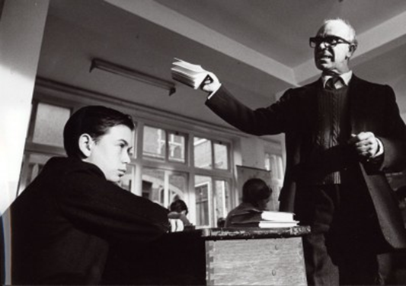
Kevin McKeon as young Pink, Alex McAvoy as the teacher.

Much like the torturous subject of the album itself, production of the film would be labelled as hell by its crew. Waters himself initially wanted to star in the film, and use footage from his live concerts, but EMI declined to help make the project. Waters did at first star as Pink himself, but was replaced after screen tests by Bob Geldof, who personally expressed his disinterest for the role. Director Parker, screenwriter Waters and animator Gerald Scarfe had frequent clashes during production (with cinematographer Michael Seresin abandoning the project); Parker called it ‘one of the most miserable creative experiences of [his] entire life’ and Scarfe routinely drank whiskey before going to work- (‘I knew what was coming up, and I knew I would have to fortify myself in some way’).

In many ways you could say that it's no surprise that the film at the time was not a box office hit, given its largely dystopian tone which the Thatcherite Britain had abandoned in favour of a more joyful and capitalist property owning democracy which clashed with the political eras in which the film was based (such as Clement Attlee’s austere post-war government). Indeed, in terms of mainstream success and the development of new albums (if not in album sales), Pink Floyd had become outdated to an extent, a fact demonstrated by the band’s change in direction after 1982’s The Final Cut, after which Waters departed from the band. After this Pink Floyd would continue under David Gilmour, the band’s lead vocalist.
It was however successful given its limited release (it entered no.28 of the US box office charts despite only being shown in one theatre) and was given positive, if not astounding, reviews by critics: Roger Ebert stated that it was ‘difficult, painful and despairing… filming this material could not have been a happy experience for anyone’ and Gene Siskel was enamoured with the imagery of the fascist rally. However, many thought the film to be repetitive and difficult to watch in its dreary nature.

Final Thoughts

The Wall has continued to be an enduring presence in Pop culture, and was setting records decades after its release. Waters and the rest of Pink Floyd were inducted into the Rock and Roll Hall of Fame in 1996. The Wall- Live in Berlin in 1990 was one of the largest rock concerts in history, hosting 450,000 people, and his Wall Live Tour of 2010-13 was the highest grossing tour of any artist up to that point, netting at least $100 million.

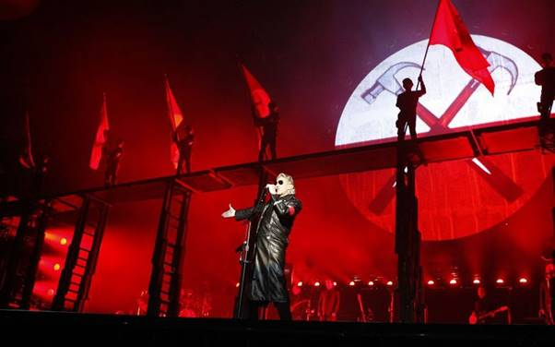
This was mainly done for the benefit of me understanding the album better- if you want an even more in-depth analysis I would recommend thewallanalysis.com, which is incredibly useful and presented in a readable format.

The reason for this- I am not an expert on Pink Floyd or their music, and I could never have been able to go over the background of these songs as thoroughly as I have without developed internet sources. But hopefully with my inclusion of my personal thoughts on the song to make it more of a project (instead of just listing things I found online) I have been able to demonstrate how subjective and interpretive Pink Floyd’s music is- it means many things to many different people. The band didn’t follow the same trajectory as even the most revolutionary and convention-defying bands of the period, yet their unique style (with simple yet incredible riffs and hooks) enabled them to define their musical period. Over four albums, Pink Floyd dominated and epitomised the seventies for Britain, in many ways representing the climax and fall of ten years. As the album ended and Pink’s self-imposed “wall” came down so did the UK’s entrapping cycle of industrial infighting, its fractured relationships between its leaders and its people. With the coming of Thatcherism, Britain once again broke Outside the Wall into considerable international success, winning the Falklands war and embracing American capitalism to the extent that it become the West’s secondary world power. However, this ostensive catharsis also led the UK to become a much more unequal place, with inequality still continuing to this day as Britain has the highest income discrepancy of any European country. The deeper that Thatcherism is analysed the more dubious its success seems, just as the Wall leaves Pink’s fate unknown although the audience ma theorise that he has broken out of the wall.

I chose to cover The Wall because it has the clearest link to social history within Britain, and is also Pink Floyd’s single biggest franchise, with a cohesive story. However, it is a tribute to the band that as famous as the album and its following is, whether it is their best work is still debatable. Evidence of this is that I nearly got carried away in attempting to cover Wish You Were Here (my personal favourite) as well- I also have Dark Side of the Moon on vinyl and have listened to it innumerable times. It offers a more general analysis of life and its highs and lows (capitalism through Money, ageing through Time, the random nature of friendship through Us and Them, heaven through The Great Gig in the Sky) which is really intriguing. It’s a testament to the band that their album can be hard to listen to, especially for those who prefer their music only as uplifting motivation and not a sobering analysis of life as the band experiences it. However, I would encourage anybody to listen to Pink Floyd, and don’t get thrown off by the long songs- I think that they are some of the most engaging ever created.

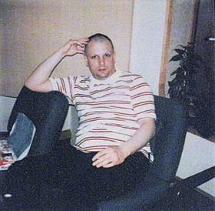
This was fun to do- I get a bit obsessive about music, and especially musical history: there are so many bands which I would love to do this with. None have more acutely linked their music to the losses in their personal lives however, the obstacles (like corrupt musical producers on WYWH’s Have A Cigar) they had to overcome. I think that the visual aspect of shaven heads for the dictators may even reference the appearance of Syd Barrett himself, who completely isolated himself from the world and the band in 1972. Much of Pink Floyd’s music is made in his memory. The band’s work, however dystopian, in based in real life- much of the Wall is about Pink’s estrangement with his family, something he experienced with the death of his dad and his struggles with relationships (he has been married four times).

Syd Barrett in 1975

