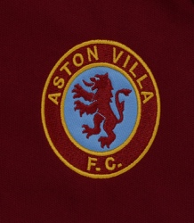
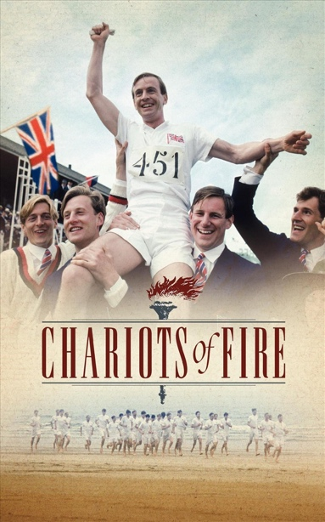
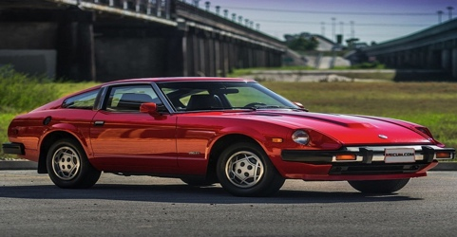
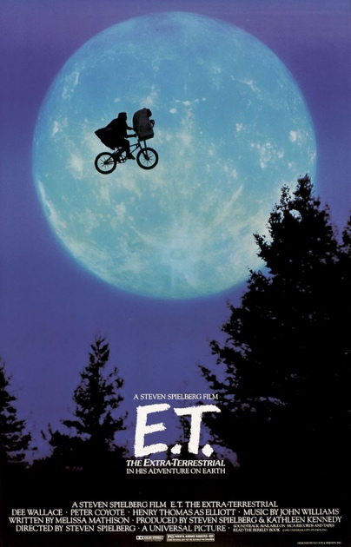
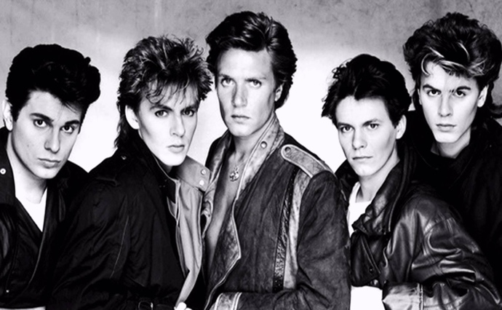
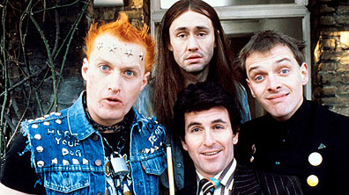
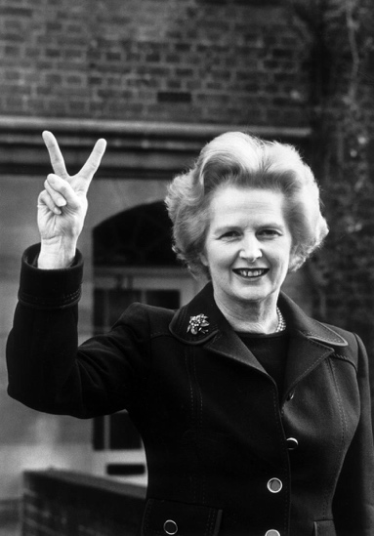

Why was 1982 was the best year to turn 18?

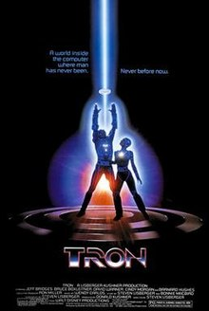
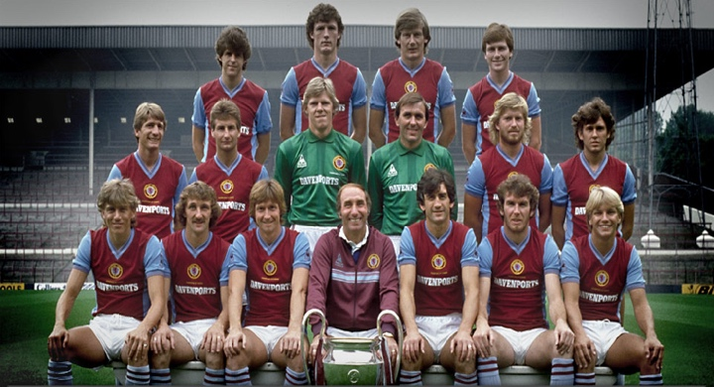
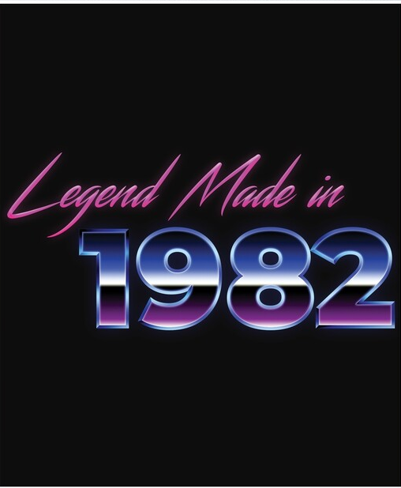
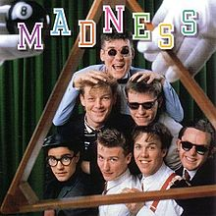
By Max Holton

Today, I shall convince you (the beneficiaries of my knowledge), that 1982 was the best year to turn 18. It only takes on look at the front cover of this document to realise what a great year 1982 was in itself. It’s also important to understand how an 18-year-old in 1982, can reap the benefits of certain occurrences throughout the 1980’s as a man in his 20’s.

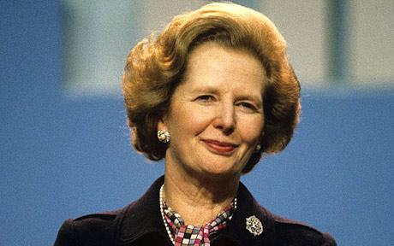
The refreshing end of the anachronistic cobwebbed post war consensus led to a more meritocratous society. There was a well-known saying that if your father was a coal miner you didn’t have to be one. This was ideal for an 18-year-old who wasn’t born into the ruling class, who wanted to strive in this meritocratous society. The quote, “I believe you have a saying in the Middle West: ‘Don't cut down the tall poppies. Let them rather grow tall.’ I would say, let our children grow tall and some taller than others if they have the ability in them to do so. Because we must build a society in which each citizen can develop his full potential, both for his own benefit and for the community as a whole, a society in which originality, skill, energy and thrift are rewarded, in which we encourage rather than restrict the variety and richness of human nature”, perfectly encapsulates the kind of society that Thatcher was aiming to create in 1982, which would have been opportune for an 18 year old.

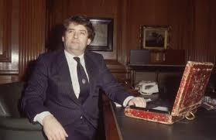
As an 18-year-old in 1982, going into the world of employment, you would be able to reap the benefits of a reduction in taxation. Lawson’s budget cut the base rate of taxation from 33% to 30%, as well as cutting the top rate from 83% to 60%. Later on, the top rate would be cut to 40% and the base rate would be cut to 25%, which going into your 20’s would have been beneficial as a young worker. Also, as a middle-class child, I would point to the statistic that middle-class families wealth increased by 26% throughout the 80’s, suggesting that the 80’s were of great importance in growth of middle-class families. Tax cuts by Thatcher throughout the 1980’s allowed for the growth of a more materialist and consumerist society, where I feel as an 18-year-old, I would fit in.

Furthermore, with the possibility of going into the financial circle when I am older, one would argue that Thatcher’s revolution for the middle class would have provided great opportunities for an ambitious

20-year-old in the financial field. The rise of ‘invisible earnings’ and the freeing of the City of London from the tight controls of the Bank of England, led to greater wealth opportunities. By 1988, the UK volume of financial trading had increased by 15 times, from its levels in 1979. Greater financial speculation led to the creation of a ‘new super rich class’ in the worlds of Andrew Marr.

1982 also was the release of many historically significant songs, most notably, Save A Prayer, and Rio by Duran Duran, a band from Birmingham, which one would suggest ushered in a new era of music videos and also a new era of UK pop music, which was perfectly highlighted by their subsequent music videos, which accompanied their hits. They were a major part of the ‘New romantic’ era of pop music, along side Spandau Ballet.
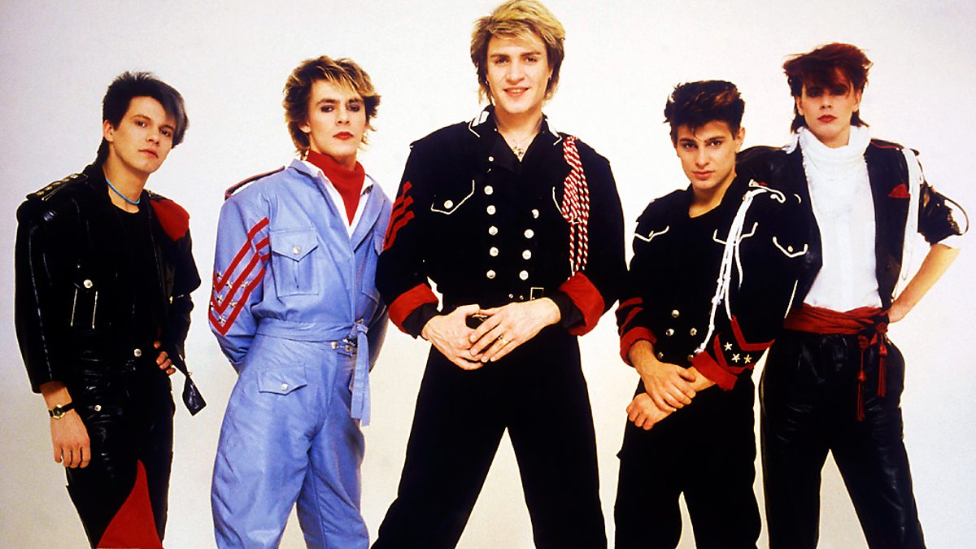

Duran Duran in 1982. From the left, Andy Taylor, Nick Rhodes, Simon Le Bon, Rodger Taylor & John Taylor

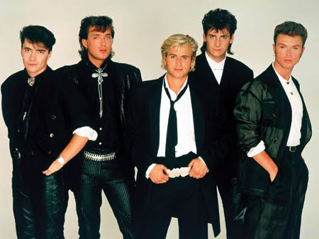

Spandau Ballet in 1982. From the left, John Keeble, Martin Kemp, Steve Norman, Tony Hadley & Gary Kemp

Also, in terms of music, 1982 saw the release of other prominent UK singles, including House of Fun, by Madness. The song spent 9 weeks in number 1 spot on the UK singles charts. Quite relevantly, the song is about coming of age, and a boy on his 16th birthday attempting to by condoms at a chemist, however, the chemist misunderstands him, and redirects him to the ‘house of fun’. This popular tune highlights the freer society there is by 1982, highlighting the attitude of the youth.


The most successful period for the band was from 1980–1986 when Madness spent 214 weeks on the UK singles charts.

Madness have had 15 singles reach the UK top ten, which include "One Step Beyond", "Baggy Trousers" and "It Must Be Love", one UK number one single "House of Fun".

Madness are an English ska band from Camden Town, north London, who formed in 1976. One of the most prominent bands of the late 1970s and early 1980s two-tone ska revival, they continue to perform with six of the seven members of their original line-up.

As an 18-year-old, in 1982, you were exposed to a new type of film, centering round Sci-Fi as a genre. With the concept of space still being a relatively unknown and intriguing thing, three films benefitted from this intrigue. The release of Blade Runner was encapsulating for the older teenage generations, similar to the Fast and Furious franchise of today. The film is set in a dystopian future Los Angeles of 2019, in which synthetic humans known as replicants are bio-engineered by the powerful Tyrell Corporation to work on off-world
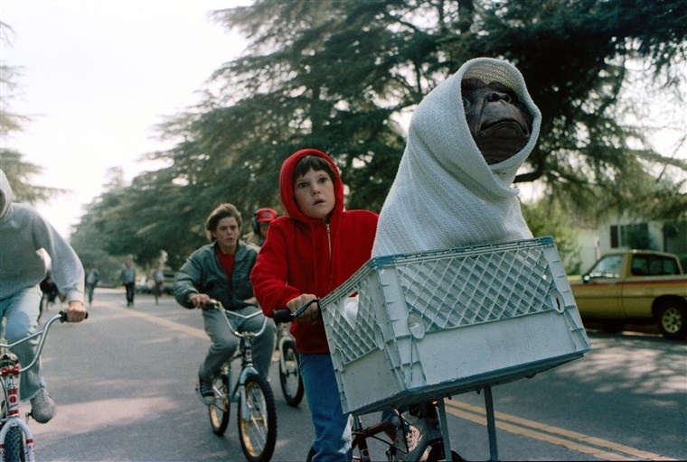
colonies. When a fugitive group of advanced replicants led by Roy Batty escapes back to Earth, burnt-out cop Rick Deckard (Harrison Ford) reluctantly agrees to hunt them down. Also, Tron, which stars Jeff Bridges as a computer programmer who is transported inside the software world of a mainframe computer where he interacts with programs in his attempt to escape. However, most importantly, E.T. was the movie that left the biggest mark on each generation, with many flocking to cinema’s to see its release. Fir me, E.T. perfectly sums up the interests of the average 18-year-old in 1982. $1.33 billion was made from ticket sales for E.T.

Also, stepping away from the Sci-fi genre, as an 18-year-old in 1982, I would be eager to watch the newly released chariots of fire in the cinema, highlighting British tradition and sporting success.

With the likes of the Porsche 911 SC, 1982 Jeep CJ and the infamous Datsun 280ZX, 1982, can be seen as promising time for 18-year olds, with infamous cars to aim towards, at the dawn of this new consumerist society.


A 1982 Porsche 911 SC


Jeep CJ

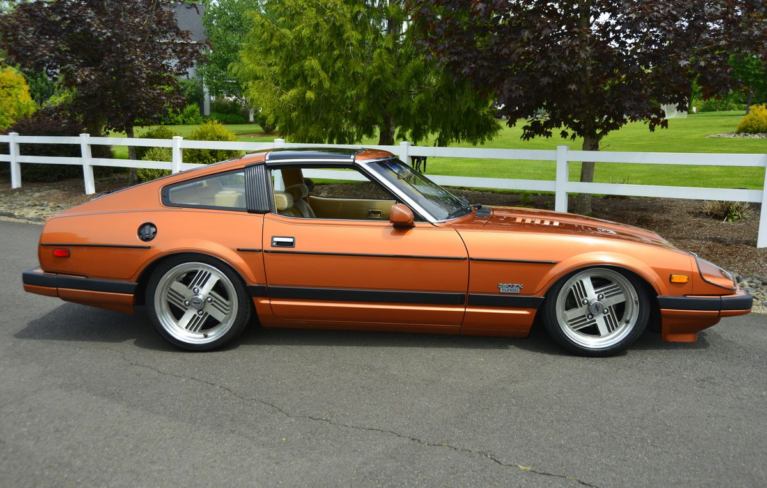

Datsun 280ZX

From a personal perspective, 1982 was the best year to turn 18, as it saw my boyhood club Aston Villa lift the European Cup, after a 0-1 win against Bayern Munich in Rotterdam. Peter Withe’s goal in the 67th minute was perfectly commentated on by Brian Moore, which is displayed across the North Stand at Villa Park. It reads, ‘Shaw, Williams, prepared to venture down the left. There's a good ball in for Tony Morley. Oh, it must be, and it is! It's Peter Withe.’ To be an 18-year-old, traveling to Rotterdam on that glorious European night would have been the highlight of my life, which is part of the reason why for me 1982 was the best year to turn 18. To start off your adult life travelling to Rotterdam to watch your boyhood club lift the most prised possession in club football would have been a dream come true.
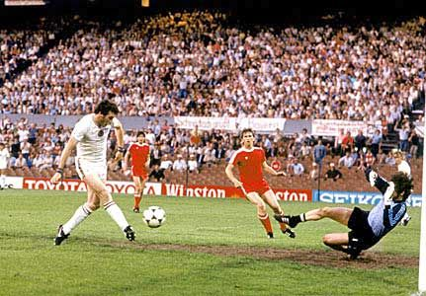

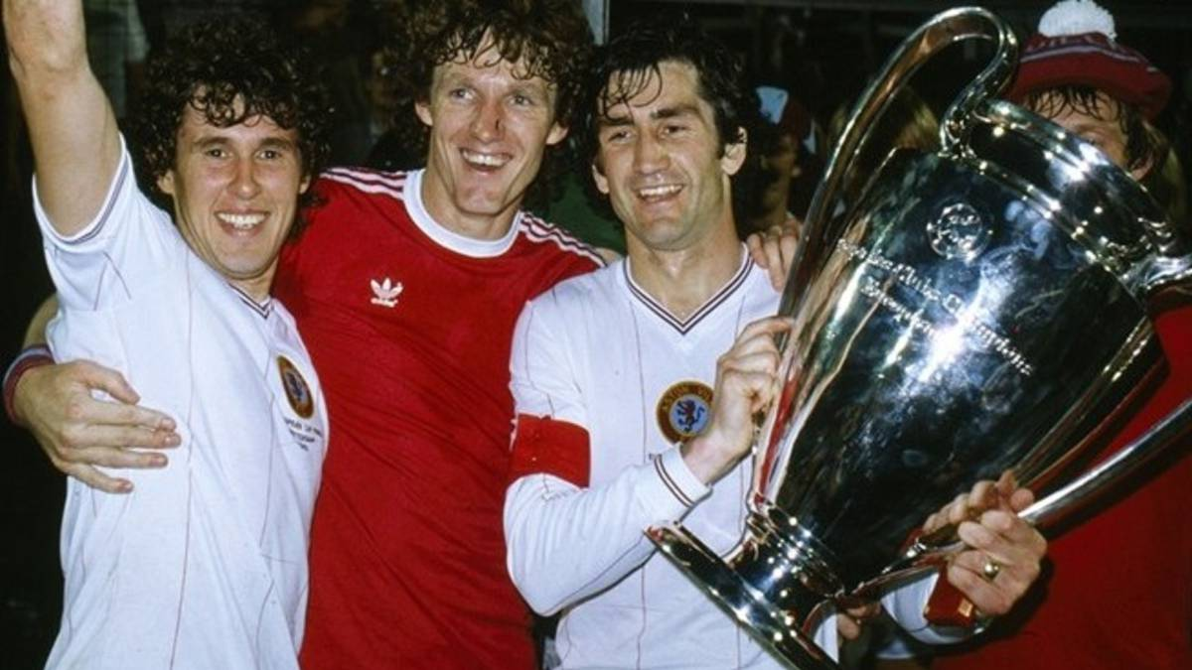

In 1982, the British population was graced by the appearance of four plucky young university students, Rick, Vyvyan, Neil and Mike, who attended scumbag college. The show often involved anarchic and off beat humour. The Young Ones helped bring alternative comedy to British television in the 1980s and made household names of its writers and performers. The show became a notable icon of 1980s British popular culture and received its own game and a home-media release, while becoming the first non-music-related programme to appear on MTV in 1985. The show was voted number 31 in the BBC's Best Sitcom poll in 2004. It’s alternative comedy was perfect for young adults viewing.



